Work Tracking

A simple way for recording working times for different tasks…

…with different locations

Ein Bild, das Text, Elektronik, Screenshot enthält.

© 2021 Dr. Valentin Illich,

[valentin.illich@web.de](mailto:valentin.illich@web.de)

# Table Of Contents

Table Of Contents 2

1. How It Works 3

1.1 Main Window 3

1.2. Operating Principles 4

2. Creating Entries 4

3. Recording Working Time 5

4. Correcting Working Time 5

5. Deleting Entries 6

6. Showing Weekly Times 6

6.1. Filtering kinds of work 7

6.2. Filtering work Items 7

6.3. Showing Work in Percent 7

7. Showing Monthly Times 7

8. Showing Yearly Times 8

9. Exporting to Clipboard 8

9.1. Including of recreation times 9

10. Creating Default List 9

11. Changing Language 9

# 1. How It Works

The Work Tracking application is a small tool which helps you to keep an overview about your work: What you are working on, how much you are working on and where you are currently doing this.

There are two kinds of work, namely Office and Home. These kinds may be tracked separately so that you will be able to create a list of homework only or office work only or more.

The Work Tracking application provides a recording function for easy change between several tasks with two clicks. It also allows you to modify times already recorded in the past. This allows you to deal with company time recordings which are done outside this tool.

Recorded times may be exported via clipboard into EXCEL tables for further processing. This may be done per week, month or even year.

You may also define a default list of work items for each new day so that you just can start with one click.

## 1.1 Main Window

The main window shows all information needed to get an overview about the current work.

Ein Bild, das Text, Elektronik, Mobiltelefon, Screenshot enthält.

2)

3)

1)

There are 3 main areas with all elements needed for daily operations:

1. In the navigation area you can change the current time period. The period can be changed between day, week, month and year by menu selection
2. In the tracking area you can see the current work items with their time spent. Here you can quickly start / stop the recording function but also correct already recorded times
3. In the menu area you can change the period, the current location, the calculation method and so on. You also can add new items to the list.

## 1.2. Operating Principles

For convenient operation, you just must know about following three things:

### Kinds of Work

Currently the application supports two different kinds of work. **Office work** means all work you do in the office and normally will be tracked by an external company system. Nevertheless, it is important to track it here, too. This allows you to get a complete summary overview for weeks, months and years if needed. **Homework** means all work you do outside the office where this application is the only tracking method. This of course also means mobile work or travel times you get paid for.

### Recording Function

The recording function will surely be the most used function of the application: As soon as you have defined some default work items you will get them per default for every new day. Then you just start and stop the recording by just one mouse click. The picture of the main window above e.g., shows that “WorkTracker” is the current work item where the recording is active. The other two work items currently are inactive, that means no time is recorded.

### Correction Function

Of course, it will happen that you forget to start or stop a recording at the right moment. But this is no problem: The application allows you to correct the recorded times at any time, even while a recording is active.

# 2. Creating Entries

If you need to create a new entry you just press the “+” button on the bottom. You then get a new dialog where you can enter the information needed:

Ein Bild, das Text, Monitor, Elektronik, Screenshot enthält.

Just enter a title and press OK to get a new active item in the list. You also may select an appropriate kind of work and an already spent amount of time if you want.

# 3. Recording Working Time

You always can start / stop the recording of a work item by clicking the slide switch on the right-hand side. An item with active recording is shown in green color, inactive items are shown in normal color.

Active items also are showing the current selected kind of work for the recording. You may change this by clicking the menu button “…” and changing the combo box entry inside the menu:

Ein Bild, das Text, Monitor, Screenshot enthält.

# 4. Correcting Working Time

If you must correct your working time for any reason, just click onto a work item in the list and you will get an expanded view with additional controls.

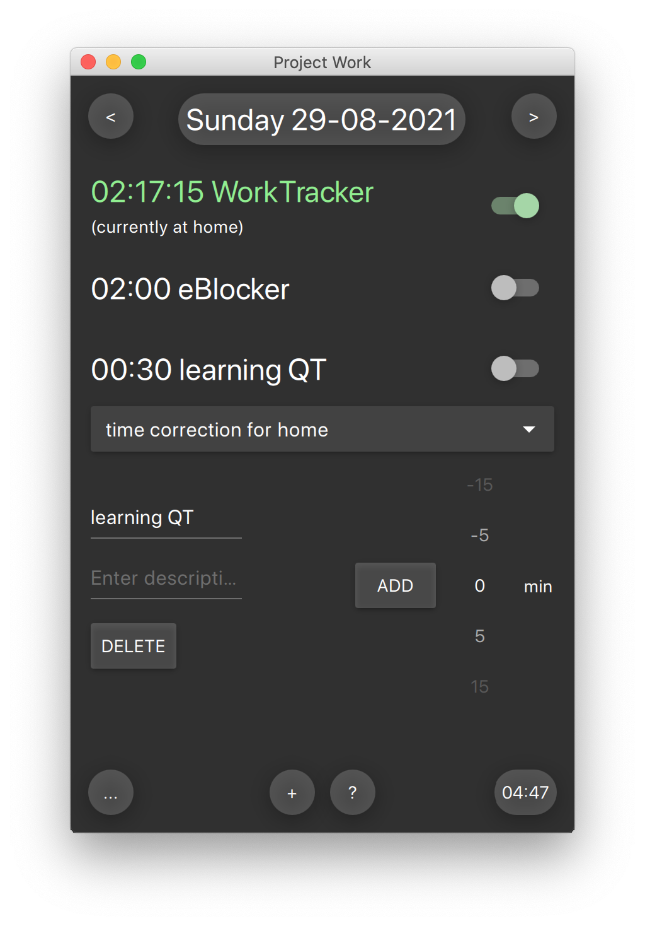

Here you can change the title, enter an additional description, and add a time correction in minutes for this item. Please be aware that you must select the correct kind of work before you use the correction function. Otherwise, the summary times would get wrong (see below).

When clicking again onto the item, it will be collapsed again.

# 5. Deleting Entries

If you want to delete a work item in the list, just expand it by clicking onto it and then press the “Delete” button.

Normally, you should need this function only if a special work is done and you want to create a new, cleaned up default list.

# 6. Showing Weekly Times

By clicking onto the “…” button and by selecting “Overview of week” you will get a summary about your work in the current calendar week:

Ein Bild, das Text, Elektronik, Screenshot enthält.

## 6.1. Filtering kinds of work

Per default, all work items per day and all kinds of work are summarized here to get a complete overview. But you also may filter the kinds of work shown within the menu:

Ein Bild, das Text, Monitor, Screenshot, silbern enthält.
Ein Bild, das Text, Elektronik, Screenshot enthält.
Ein Bild, das Text, Elektronik, Screenshot enthält.

Just (de)select the interesting kind of work and press “OK” then. The summary will automatically change (shown here: home only with 21:48, office only with 11:00)

## 6.2. Filtering work Items

You also may be interested in the exact distribution over your different work items. Then you can set the check mark in “always show work items”:

Ein Bild, das Text, Elektronik, Screenshot enthält.
Ein Bild, das Text, Elektronik, Screenshot enthält.

## 6.3. Showing Work in Percent

By clicking onto the summary button, you can change between absolute hours and a percentage (as shown in the right image above).

The filter function for kind or work, the always show work function and the percentage display function is available in all types of overviews.

# 7. S

# howing Monthly Times

If you select “Overview of month”, you always get a list of all work items with the summary of spent time.

Ein Bild, das Text, Telefon, Mobiltelefon, Screenshot enthält.

Per default, all kinds of work are summarized here to get a complete overview. But you also may filter the kinds of work shown within the menu, see description in “Show Weekly Times”.

# 8. Showing Yearly Times

If you select “Overview of year”, you get a list of months resp. all work items with the summary of spent time.

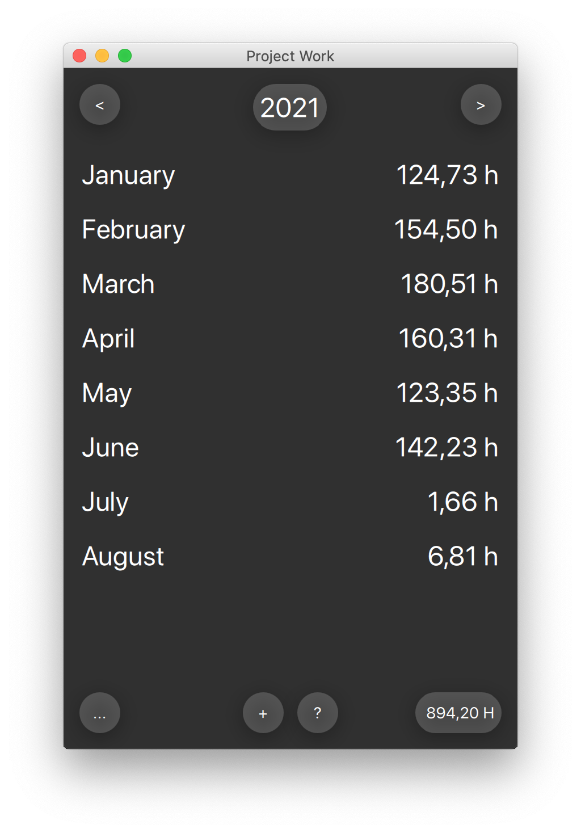 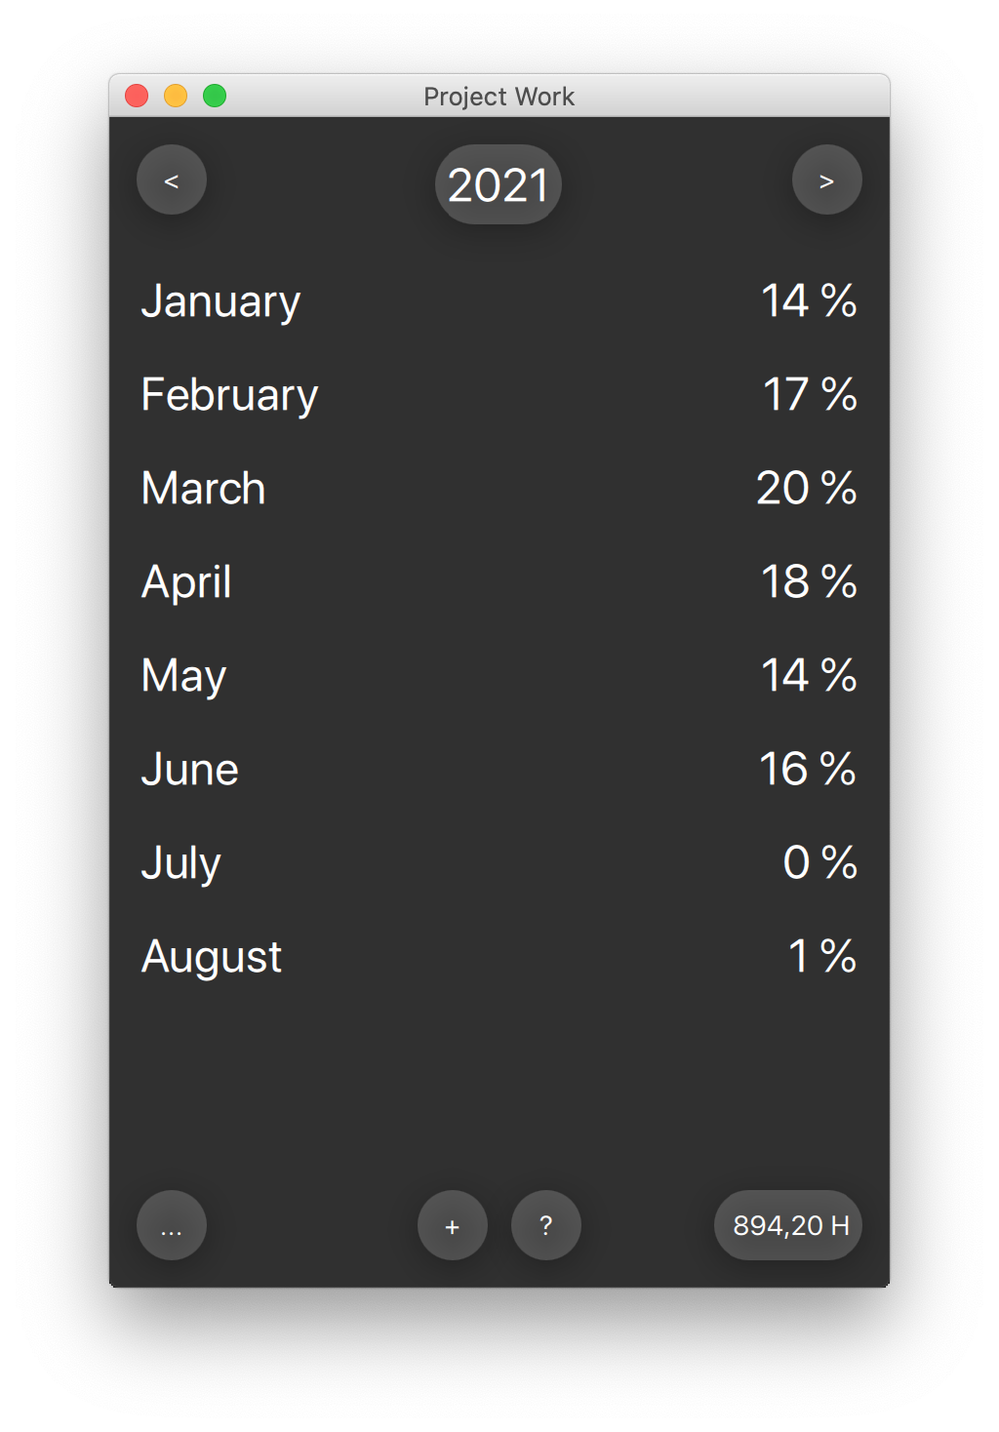

Per default, work items per month and all kinds of work are summarized here to get a complete overview. But you also may filter the kinds of work shown within the menu, see description in “Show Weekly Times”.

# 9. Exporting to Clipboard

All Overview displays support an export into the clipboard so that the values can be imported into EXCEL for further processing.

According to the view settings, the export contains a list of work items or days (resp. months) with either absolute times or percentages. For example, the monthly times of the image above would be exported as follows:

Ein Bild, das Tisch enthält.

## 9.1. Including of recreation times

When exporting absolute times, the export function supports a special feature (which may only be useful in Germany due to restrictions by law): You can specify a working limit and an additional recreation time for the clipboard export. This time will be automatically added before export. The EXCEL data may then directly be used for your accounting information given to the company if they need this:

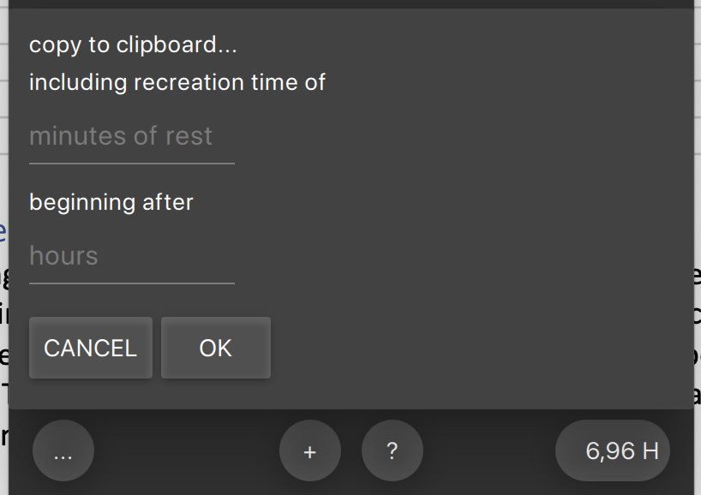

If you leave the fields empty, nothing will be added.

# 10. Creating Default List

If you have a list of work items which you want to reuse every day, you may store this list as default. With a long press on the menu button “…”, you just select “Create default from list”. On each new day, these items will be automatically filled in.

# 11. Changing Language

Currently, the Work Tracking application supports the user languages English, German, French (the latter one just as an exercise). If you would like to do a translation for more languages, please contact the author.